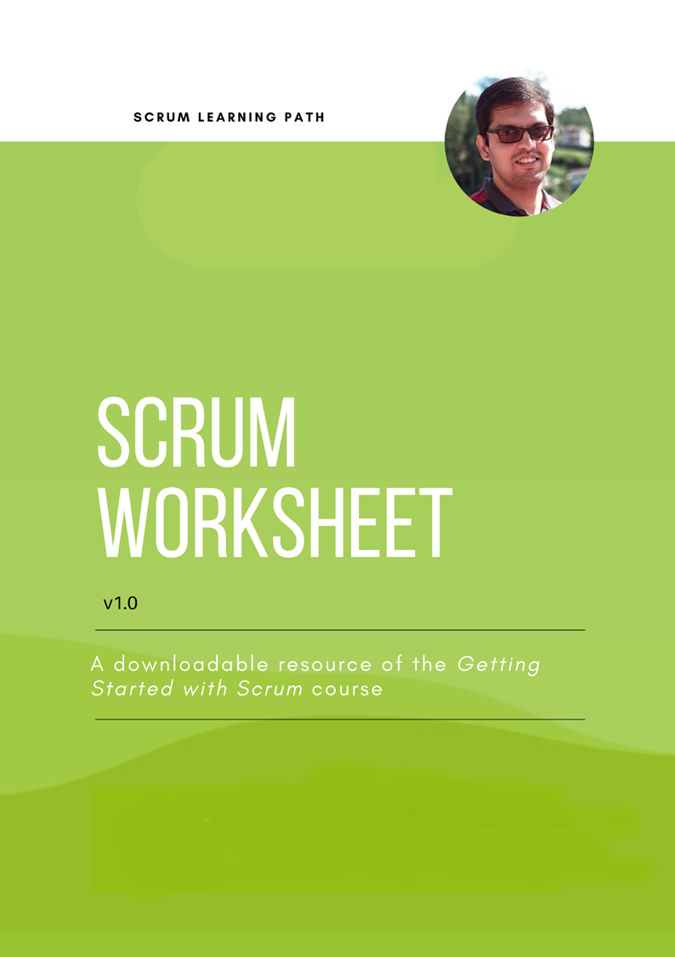

Version | Date | Details
v1.0 | 1-Apr-2022 | Initial version

Preface

Hi there!
I hope you are doing good.
I’ve created this worksheet to help you work with Scrum. You can use this to practice the various steps involved in the Scrum framework without the need for any Scrum tool. You can use this to fill the required details. If required, you can tweak them to suit your needs.
Scrum is the most popular development framework that have been increasingly adopted in any development team. This downloadable resource is part of the ‘Getting Started with Scrum’ course, which helps you to get started with Scrum using a step-by-step approach for Developers, Scrum Masters, and Product Owners.
See you in the course video!
Praveen

Table of Contents

Change History 2
Preface 3
Table of Contents 4
Step 1: Select a Product Owner 5
Step 2: Project Details 5
Step 3: Select a Scrum Master 5
Step 4: Select the Developer Team 6
Step 5: Select the Tool to Run Sprint 6
Step 6: Prepare the Sprint Tool 6
Step 7: Create a Sprint Board 6
Step 8: Create the Product Backlog 6
Step 9: Prioritise the Product Backlog Items 7
Step 10: Plan the First Sprint 7
Step 11: Hold the Sprint Planning Meeting 7
Step 12: Estimate the Sprint Backlog Items 8
Step 13: Implement the Sprint Backlog Items 8
Step 14: Hold Daily Stand-up Meeting 8
Step 15: Hold Sprint Review Meeting 9
Step 16: Hold Sprint Retrospective Meeting 9
Step 17: Repeat the Process Sprint after Sprint 9

Step 1: Select a Product Owner

Type | Details
Product Owner Name
Product Owner Email
Division
Remarks

Step 2: Project Details

Type | Details
Project Name
Organisation
Division
Start Date
End Date (expected)
Project Manager
Project Manager Email
Program Manager
Program Manager Email
Development Team Size
Remarks

Step 3: Select a Scrum Master

Type | Details
Scrum Master Name
Scrum Master Email
Division
Remarks

Step 4: Select the Developer Team

Name | Email | Divison | Remarks

Step 5: Select the Tool to Run Sprint

Type | Details
Selected Tool | Azure DevOps
Reasons for Selection | - Product development in based on Visual Studio; it has a deep integration with Azure Devops.  - Also, team uses Azure Repos for source control management.  - We can extend to use CI/CD at a later point.

Step 6: Prepare the Sprint Tool

Use TableToMarkdown to convert table in Document format to Markdown format.

Step 7: Create a Sprint Board
Backlog | ToDo | Doing | Done

Step 8: Create the Product Backlog
Product Backlog

Step 9: Prioritize the Product Backlog Items
Product Backlog

Step 10: Plan the First Sprint
Type | Details
Sprint Naming Convention
Sprint Duration
Sprint Start Day
Sprint End Day
Sprint Tool to Use
Expectations from Team

Step 11: Hold the Sprint Planning Meeting

Type | Details
Sprint Planning Date
Sprint Goal
Sprint Velocity (if known)
Participants
Venue
Workitems

Step 12: Estimate the Sprint Backlog Items
Sprint Backlog | To Do | Doing | Done

Step 13: Implement the Sprint Backlog Items
Sprint Backlog | To Do | Doing | Done

Step 14: Hold Daily Stand-up Meeting
Impediment | Person Responsible | Status

Step 15: Hold Sprint Review Meeting
Sprint Backlog | To Do | Doing | Done

Type | Details
Sprint Review Date
Participants
Venue
Kaizen

Step 16: Hold Sprint Retrospective Meeting
What went right? | What could have gone better? | What can be made better?

Step 17: Repeat the Process Sprint after Sprint
None

